Two way trust forest:

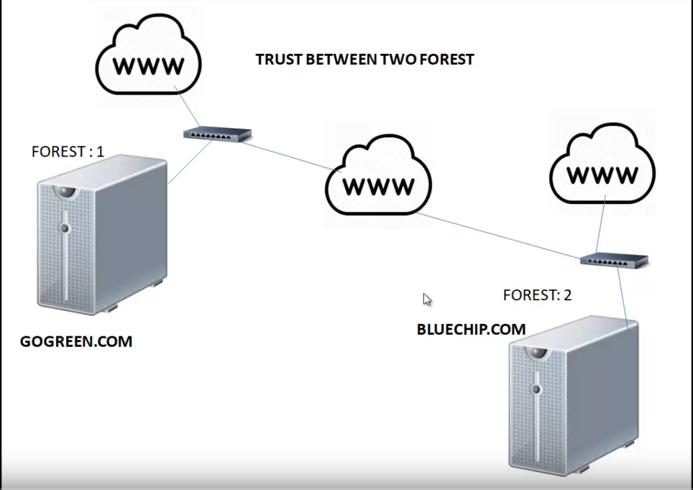

By default, these are two different forest, they won’t trust each other. You need to setup to trust each other.

If you have a child inside a forest, then it will automatically trust each other.

